Homework Project 3
Nov 14, 2015

Movable Camera in 3D Environment

Prepared By
Sean D. Alexander
Sda0009@uah.edu

Prepared For
Chao Peng, Instructor
CS 445, Intro to Computer Graphics
University of Alabama in Huntsville

Table of Contents
 | Program Description | 3
 | Main Screen | 4
Key Assignments |  | 5
Mouse Movement |  | 6
Special Keys |  | 8
Appendix I – Included Files |  | 9

Program Description

This program uses GLUT and open GL to create a 3D environment, and gives the user controls to traverse the space using a camera. The user is provided with controls to change its position, rotation, and zoom.

The program was compiled using VS2013. To compile, the cpp files need to be added to the project.

This program makes use of bmp texture maps. In order for the program to run the bitmaps must be in the active directory. See the file list for details.
Main Screen

When the program is first started two windows are brought up. One is the console window, which is of no interest to the user, and the camera window.

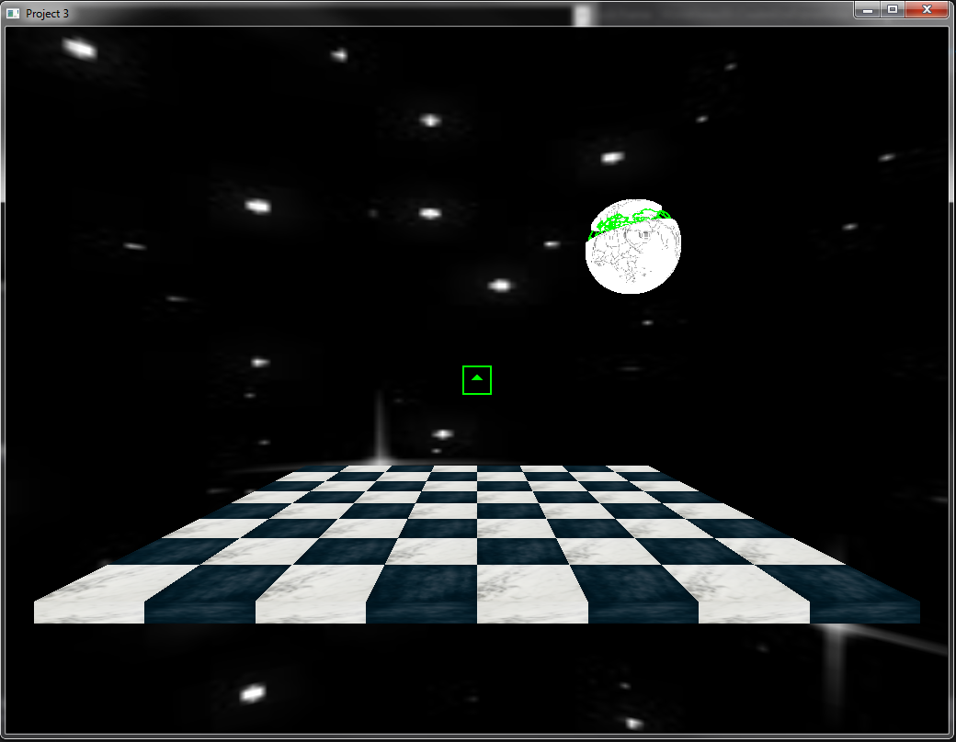
Key Assignments

WASD Keys

The W, A, S, and D keys move the camera along the vectors based on the cameras rotation.

W | Move Forward | 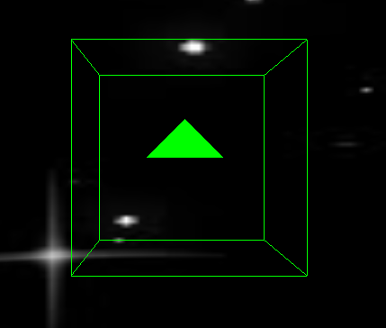  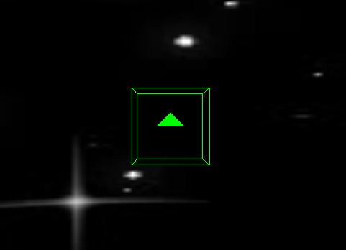
A | Move Backward
S | Move Left | 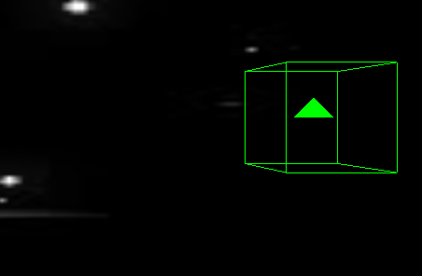
D | Move Right | 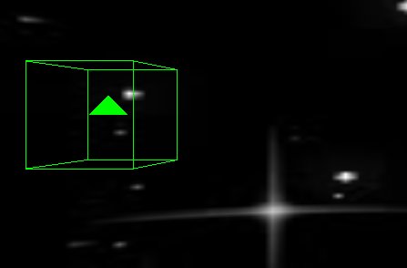

Mouse Movement

  Push left mouse button while  Mouse Forward-Back | Rotate Camera on the U Axis
Push left mouse button while  Mouse Forward-Back | Rotate Camera in the V Axis
  Push Middle button while moving the mouse up-down and left-right. | Move or “Pan” the camera in the V and U Axis
  Roll the mouse wheel | Move the camera towards/away from the look at point.
  Push left mouse button while  Mouse Forward-Back | Rotate or “Orbit” the camera around the look at point.

Special Keys

m | Cause the chessboard to move.
x | This command will quit the program.

Appendix I – Included Files
File Name | Description
Main.cpp | The file that contains the main routine, as well as the glut input callback functions, visual setups, and instantiations of support objects.
ChessSquare.h  ChessSquare.cpp | This file contains the texture mapping and draw functions to create a “ChessSquare” instance.
CameraObject.h  CameraObject.cpp | This file contains the object that generates the camera object. This file contains the math functions to describe its position and angles, and provides the methods for changing those properties.  This program requires the glm library!
BMPReader.h  BMPReader.cpp | These files contain an object for reading BMP files.
blue-marble512x512.bmp  starmap.bmp  TBWM02_LB_BlankOutlineWorldMap.bmp  WhiteMarble512x512.bmp | These are image files that are used by the program for texture mapping.  The program will not load if these files are not in the active directory.

